Create Table facebook

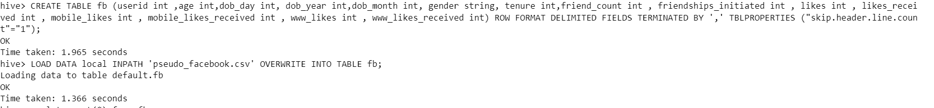

Q1: Find out the total no of users in the dataset

Q2: Find out the no of users above the age of 25

Q3: Do male face book users tend to have more friends or female users

Q4: How many likes do young people receive on facebook as opposed to old people

young people - minors age<19

old people - adults age>18

Q5: Find out the count of facebook users for each birthday month

Q6: Do young members use mobile phones or computers for facebook browsing

Q7: Do adult members use mobile phones or computers for facebook browsing

